Geometry: Unit 7, Lesson H3
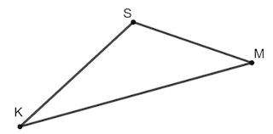
- $∆SMK$ is shown where $SM=10$, $SK=12$, $KM=18$. What is the measure of $∠KMS$, rounded to the nearest tenth?

$$m∠KMS=38.9°$$

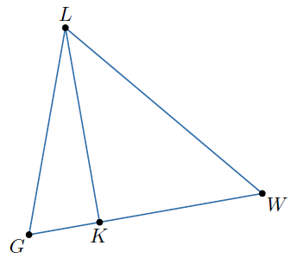

- Triangle $LWG$ is shown where $GW=6$ feet (ft) and the area is $15 {ft}^{2}$. What is the height of the triangle, $\overline{KL}$?

$5$ft

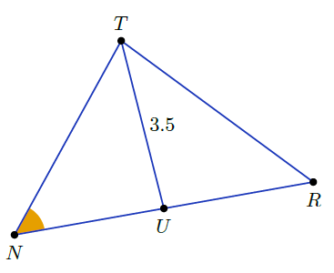
- $∆TRN$ is shown with an altitude, $\overline{UT}$, of $3.5$. What is the side length needed to find the area of $∆TRN$?

$$\overline{NR}$$

